

**NATIONAL CERTIFICATE**

# FITTING AND MACHINING THEORY N2

(11022032)

**9 April 2021 (X-paper)**

**09:00–12:00**

**Calculators and drawing instruments may be used.**

**This question paper consists of 10 pages and 1 formula sheet.**

104Q1A2109

## DEPARTMENT OF HIGHER EDUCATION AND TRAINING

**REPUBLIC OF SOUTH AFRICA**

NATIONAL CERTIFICATE

FITTING AND MACHINING THEORY N2

TIME: 3 HOURS

MARKS: 100

**NOTE:** If you answer more than the required number of questions, only the required number of questions will be marked. All work you do not want to be marked, must be clearly crossed out.

### INSTRUCTIONS AND INFORMATION

1. Answer all the questions in SECTION A, except for QUESTION 1 where you must answer either QUESTION 1.1 or QUESTION 1.2.

1. Answer only TWO questions in SECTION B.

1. Number the answers according to the numbering system used in this question paper.

1. Write neatly and legibly.

**SECTION A**

### QUESTION 1: OCCUPATIONAL SAFETY

NOTE: Answer ONLY QUESTION 1.1 or QUESTION 1.2.

1.1 Indicate whether the following statements are TRUE or FALSE by writing only

'True' or 'False' next to the question number (1.1.1–1.1.5) in the ANSWER BOOK.

1.1.1 No person shall fit a grinding wheel unless the manufacturer's rated minimum speed in revolutions per minute is clearly marked on the wheel.

1.1.2 A strong person may climb a ladder using one hand. 

1.1.3 Grinding wheels are to be mounted concentrically onto the spindle.

1.1.4 Compressed gas cylinders must be stored in a well-ventilated area away from heat and direct sunlight.

1.1.5 It is not necessary to install a guard around a V-belt.

(5 × 1) **[5]**

### OR

1.2. Indicate whether the following statements are TRUE or FALSE by writing only

'True' or 'False' next to the question number (1.2.1–1.2.5) in the ANSWER BOOK.

1.2.1 No person shall smoke in the workings of a fiery mine.

1.2.2 A valid drivers’ license is the only requirement for a worker to drive a vehicle on a mine.

1.2.3 All machinery, when in motion, must be securely fenced off to prevent a danger to any persons.

1.2.4 A weight can be placed on a safety valve to keep the pressure in the boiler constant.



1.2.5 Every employee is responsible for their own safety as well as the

safety of their fellow workers.

### (5 × 1) [5] QUESTION 2: COUPLINGS

2.1



**A**

**FIGURE 1**

2.1.1 Name the coupling shown in FIGURE 1.

2.1.2 To which group does this coupling belong?

 2.1.3 Name the part labelled A.

(3 × 1) (3)

2.2 State the group into which each of the following couplings fall:

2.2.1 Chain coupling

2.2.2 Spider coupling 

2.2.3 Universal coupling

(3 × 1) (3)

**[6]**

### QUESTION 3: LIMITS AND FITS

3.1 Describe the following fits with reference to how the mating parts fit relative to each other:

3.1.1 Push fit

3.1.2 Running fit

3.1.3 Sliding fit 

3.1.4 Press fit

(4 × 1) (4)

3.2 Define the following terms:

3.2.1 Bilateral tolerance 

3.2.2 Unilateral tolerance

3.2.3 High limit

(3 × 1) (3)

**[7]**

### QUESTION 4: BEARINGS

4.1 State THREE causes of noisy roller bearings. (3)



4.2 Name TWO disadvantages of anti-frictional bearings. (2)

**[5]**

### QUESTION 5: LUBRICATION AND VALVES

5.1 Explain what is meant by the following lubrication terms:

5.1.1 Rubbing speed

5.1.2 Adhesion



5.1.3 Viscosity

(3 × 1) (3)

5.2 Explain the working principle of a valve. (3)

**[6]**

### QUESTION 6: PACKING, STUFFING BOXES, JOINTS AND WATER PIPE SYSTEMS

6.1 State FIVE reasons for lagging water and steam pipe lines. (5)

6.2 List FOUR joining methods for steel water pipes. (4)

### [9] QUESTION 7: PUMPS

7.1 FIGURE 2 shows diagrams of two pumps. Study the diagrams and answer the questions.

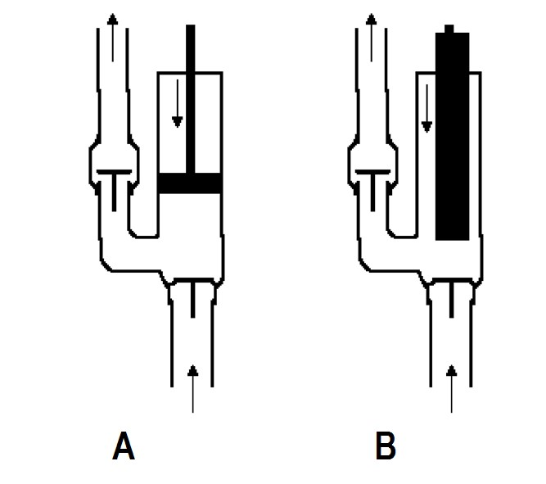

**FIGURE 2**

7.1.1 Name the pumps labelled A and B in FIGURE 2. (2)

7.1.2 State the category under which these pumps are classified. (1)

7.1.3 State the type of displacement that occurs in these pumps.  (1)

7.2 State TWO reasons why the impeller of a centrifugal pump is designed with

backward curved vanes. (2)

**[6]**

### QUESTION 8: COMPRESSORS

State the function of the following components of a compressed air system:

8.1 Air filter

8.2 High pressure cylinder

8.3 Drain valve



8.4 Cotter

### (4 × 1) [4] QUESTION 9: V-BELTS, GEAR DRIVES, CHAIN DRIVES AND REDUCTION GEARBOXES

9.1 State the main function of a V-belt. (1)

9.2 Explain the meaning of the following V-belt drive terms:

9.2.1 Arc of contact



9.2.2 Driven pulley

(2 × 1) (2)

9.3 State THREE disadvantages of gear drives compared to V-belt drives. (3)

9.4 Name ONE instance where the use of chain drives is preferred over:

9.4.1 Gear drives

9.4.2 Belt drives

(2 × 1) (2)

9.5 List TWO disadvantages of chain drives (2)

9.6 State TWO ways to ensure that bearings on gearboxes are maintained in good

working order. (2)

**[12]**

**TOTAL SECTION A:** **60**

**SECTION B**

Answer ONLY TWO of the following questions.

### QUESTION 10: HYDRAULICS AND PNEUMATICS

10.1 Choose an item from COLUMN B that matches a description in COLUMN A. Write only the letter (A–E) next to the question number (10.1.1–10.1.5) in the

 ANSWER BOOK.

|  |  |  |  |
| --- | --- | --- | --- |
|  | **COLUMN A** |  | **COLUMN B** |
| 10.1.1    10.1.2      10.1.3        10.1.4      10.1.5 | The force per unit area    Allows fluid flow in one direction only    The quantity of compressed air circulating through a given  cross-section in unit time    Protects the hydraulic system  from excessive pressure    Alerts, generates and cancels signals in a hydraulic system | A    B    C    D    E | check valve    pressure relief valve    pressure    control valve    flow |

|  |  |  |
| --- | --- | --- |
|  | (5 × 1) | (5) |
| 10.2 Identify the following ISO pneumatic symbols: |  |  |
| 10.2.1 |  |  |

10.2.2



10.2.3

10.2.4

10.2.5

(5 × 1) (5)

10.3 Tabulate THREE differences between a hydraulic systemand a pneumatic system. Copy and complete the following table in the ANSWER BOOK.

|  |  |
| --- | --- |
| **HYDRAULIC SYSTEM** | **PNEUMATIC SYSTEM** |
|  |  |

|  |  |  |  |
| --- | --- | --- | --- |
|  |  |  |  |
| 10.4 | Name the type of displacement pump used in hydraulics. |  | (1) |
| 10.5 | State the THREE main functions of oil in a hydraulic system |  | (3) |
|  |  |  | **[20]** |

(6)



### QUESTION 11: CENTRE LATHES

11.1 Name FOUR types of lathe mandrels. (4)

11.2 State TWO disadvantages of using the graduated sleeve method when doing

taper turning on a centre lathe. (2)

11.3 A shaft with a diameter of 85 mm is machined on a lathe with a cutting speed of 45 m/min. It takes 5 minutes to execute one longitudinal cut along the shaft. The feed of the cutting tool is 0.8 mm per revolution.

Calculate the length of the shaft. (4)

11.4 FIGURE 4 shows a tapered shaft which is to be turned to the dimensions given.

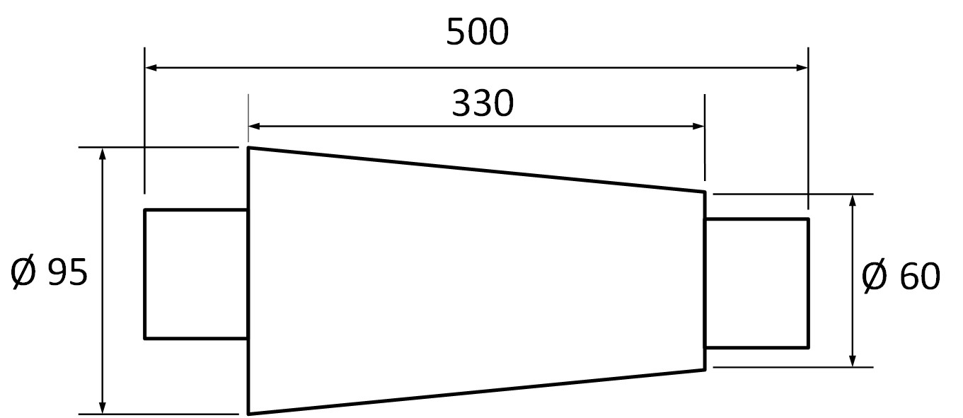

|  |  |
| --- | --- |
| **FIGURE 4** |  |
| 11.4.1 Calculate the amount of tailstock set-over.    11.4.2 Calculate the included angle of the tapered portion in degrees and | (2) |

minutes. (3)

|  |  |  |  |
| --- | --- | --- | --- |
| 11.5 | List FIVE factors to consider when writing a CNC programme. |  | (5) |
|  |  |  | **[20]** |

### QUESTION 12: MILLING MACHINES AND SURFACE GRINDERS

12.1 Explain the functions of the following milling cutters:

12.1.1 Dovetail cutter

12.1.2 Slotting cutter

12.1.3 End mill cutter



12.1.4 Slot drill

(4 × 1) (4)

12.2 List THREE reasons for using a nicked helical cutter. (3)

12.3 Calculate the required indexing for an angle of 37° using a Brown and Sharp dividing head. NOTE: Only plate 1 is available.

|  |  |  |  |  |  |  |
| --- | --- | --- | --- | --- | --- | --- |
|  | **THE BROWN AND SHARP DIVIDING HEAD** | | | | |  |
|  | **NUMBER OF HOLES** | | | | |  |
| Plate 1 | 15 | 16 | 17 | 18 | 19 | 20 |
| Plate 2 | 21 | 23 | 27 | 29 | 31 | 33 |
| Plate 3 | 37 | 39 | 41 | 43 | 47 | 49 |

(5)

12.4 Calculate the spindle speed of a milling machine using a 90 mm diameter cutter

at a cutting speed of 23 m/min. (3)

12.5 Give the meaning of the following grinding wheel terms:

12.5.1 Grit size

12.5.2 Grade 

12.5.3 Structure

(3 × 1) (3)

12.6 State TWO ways in which loading of grinding wheels can be prevented. (2)

### [20]

**TOTAL SECTION B:**  **40**

**GRAND TOTAL:**  **100**

**FITTING AND MACHINING THEORY N2**

### FORMULA SHEET

*L* =ƒ × N × t

𝜋𝐷𝑁

S = 60

𝑆 = 𝜋DN

40

N

N

9°

𝐷 − 𝑑 𝑙𝑒𝑛𝑔𝑡ℎ 𝑜𝑓 𝑤𝑜𝑟𝑘𝑝𝑖𝑒𝑐𝑒

𝑆𝑒𝑡 − 𝑜𝑣𝑒𝑟 = ×

2 𝑙𝑒𝑛𝑔𝑡ℎ 𝑜𝑓 𝑡𝑎𝑝𝑒𝑟

𝜃 𝑋

𝑡𝑎𝑛 =

2 𝐿

𝐿𝑒𝑎𝑑𝑖𝑛𝑔 𝑎𝑛𝑔𝑙𝑒 = 90° − (𝐻𝑒𝑙𝑖𝑥 𝑎𝑛𝑔𝑙𝑒 + 𝑐𝑙𝑒𝑎𝑟𝑎𝑛𝑐𝑒 𝑎𝑛𝑔𝑙𝑒)

𝐹𝑜𝑙𝑙𝑜𝑤𝑖𝑛𝑔 𝑎𝑛𝑔𝑙𝑒 = 90° + (𝐻𝑒𝑙𝑖𝑥 𝑎𝑛𝑔𝑙𝑒 − 𝑐𝑙𝑒𝑎𝑟𝑎𝑛𝑐𝑒 𝑎𝑛𝑔𝑙𝑒)

𝐿𝑒𝑎𝑑 = 𝑁𝑜 𝑜𝑓 𝑠𝑡𝑎𝑟𝑡𝑠 × 𝑝𝑖𝑡𝑐ℎ

Copyright reserved